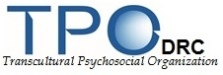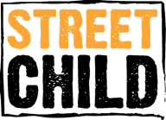

**RESEARCH PROJECT ON BEST PRACTICES AND STRATEGIES IN THE PREVENTION OF VIOLENCE AGAINST CHILDREN IN THE DEMOCRATIC REPUBLIC OF CONGO**

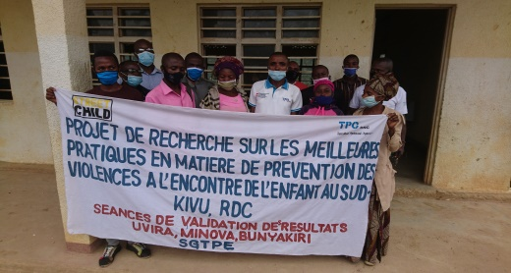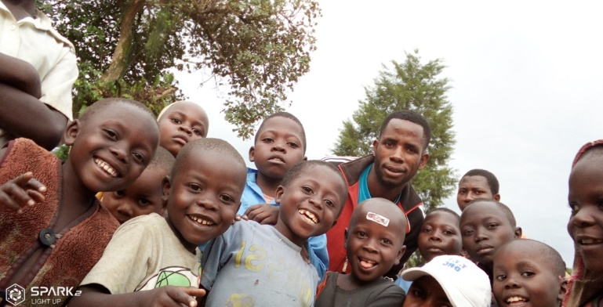

***Prepared by***

ProjectManager **: Elias Bashimbe Raphaël**

Direction**: Doris Bengibabuya H.**

Coordination**: Liliane Katindi**

Technical support**: Pierre Mweshimiwa ; Mihigo Prince**

Field survey supervision **: John Muungano; Yunusi Nyandinda; Christian Monga**

**Funded by  : Street Child**

**Implementation: TPO-DRC**

**South Kivu-DRC, July 2021**

[**www.tpodrc.org**](http://www.tpodrc.org) **,** [**info@tpodrc.org**](mailto:info@tpodrc.org)

CONTENTS

**LIST OF TABLES** 2

**LIST OF PICTURE** 3

**ACKNOWLEDGEMENTS** 4

**Acronymes** 5

**SUMMARY** 6

**I.** **INTRODUCTION AND STUDY CONTEXT** 1

INTRODUCTION 1

CONTEXT OF THE RESEARCH 4

**1.1.** **Objective of the research** 4

**1.2.** **Specific Objectives** 4

**II.** **RESEARCH APPROACH AND METHODOLOGY** 4

**2.1.** **Area of study** 4

**2.2.** **Data Collection** 5

***2.2.1.*** ***Data Collectors selection and training*** 5

**2.2.2.** **Uded methods** 5

**2.2.3.** **Data Collection techniques** 5

**2.2.4.** **Inclusion criteria** 6

**2.2.5.** **Data nalysis** 6

**2.2.6.** **Ethical considerations** 7

**2.2.9.** **Conflit of interest** 8

**3.1.1.** **Characteristics / Profile of Respondents** 9

**3.1.2.** **Different forms of violations of children's rights faced by child protection actors in South Kivu in DR Congo.** 9

**3.2.2.** **The main protection activities carried out at the CFS** 10

**3.2.3.** **Category of children participating to CFS’s activities** 11

**3.2.4.** **Children participation to CFS activities** 12

**3.2.5.** **Training of CFS supervisors** 12

**3.2.6.** **Tools used by supervisors for different activities in CFSs** 13

**3.3.** **CONTRIBUTION FROM LOCAL AUTHORITIES** 13

**3.3.1.** **Best practices in child protection as recognized by local authorities** 13

**3.3.2.** **Point of view of local authorities in relation to protection actions carried out by actors in their communities.** 14

**3.4.** **PARENTS AND TEACHERS’ CONTRIBUTION** 14

**3.4.1.** **Obstacles to good child protection practices in South Kivu province, DRC.** 14

**CONCLUSION** 0

**6. RECOMMENDATIONS AND LESSONS LEARNED** 1

**REFERENCES** 2

**APPENDIX I. THEMATICS ADDRESSED IN CHILD PROTECTION** 3

**APPENDIX II. INTERVIEWED STRUCTURES** 3

**APPENDIX III. DATA COLLECTION TOOLS /SURVEY QUESTIONNAIRES** 5

# **LIST OF TABLES**

Table 1: Number of people that participated in the survey ……………………………………………………………………………….9

**Table 2: Number of community structures with legal documents issued by local authorities**……………………………13

Table **3** Best practices in preventing violence against children known to local authorities………………… 13

**Tableau 4: Parents knowlegde on child protection laws** 14

**Tableau 5 Classification of best pratices in preventing violence against children in the DRC** 0

**Tableau 6 Main recommendantions formulated by local authorities to improve prevention actions and strategies implimented in the protection from violence against children in DRC.** 1

# **LISTE DES FIGURES**

**Figure 1: Forms of violations of children’s rights recognized by contacted actors according to axes** 9

# **ACKNOWLEDGEMENTS**

The present study was carried out thanks to the unconditional availability of the actors met in the field who offered their valuable time and agreed to participate actively in it. The research also benefited from the support of resource persons with proven expertise in the field of child protection. It is for this reason that we would like to thank all those from far or near that were kind enough to contribute to the research.

Our thankful words go to Street Child for the choice made of TPO to be the field implementer of this initiative with their funding. This research allowed TPODRC to carry out and / or conduct this study collaboratively opening learning opportunities in the understanding of best practices in terms of prevention of child violence across the DRC in South Kivu in particular.

To the national CPWG, Ituri, North - Kivu, South Kivu as well as organizations of the United Nations system, international, national and local NGOs for the support, the enrichment of the report and many others.

To the Congolese government, for its participation in all the research process, up to the preparation of the final report through an important multi actor workshop that confirmed the replicability and generalizability of most of the findings in the eastern DRC provinces dominated by conflict context.

We express our thanks to the teaching staff, parents, local authorities, SCPWG members (heads of NGOs, CBOs and CPCN, CFS supervisors) who availed themselves to answer our questions.

Our huge gratitude to all those who contributed to the completion of this study, with the understanding that its effective implementation will allow children and young adolescents, victims of violence, to be gratified.

# **Acronym et abbreviations**

**%  :** Percentage

**ACRWC** : The African Charter on the Rights and Welfare of the Child

**CFS  :** Child Friendly Space

**CPL   :** Child Protection Law

**CBO  :** Community Based Organization

**AGs** : Armed Group

**NGO  :** Non-GovernmentalOrganization

**OSC  :** One Stop Center

**SE** : Separated Child

**IGA :** Income Generating Activity

**TFF**  : Transitional Foster Families

**SHF**  : Spontaneous Host Family

**VSLA**  : village savings and loan associations

**OVC**  : Other Vulnerable Children

**CAAFG :** Child Associated with Armed Forces and Groups

**CRRP** : Community Risk Reduction Plan

**DRC  :** Democratic Republic of the Congo

**CPCN   :** Child Protection Community Network de

**MCRT** : Minova Community Radio Television

**CPSWG  :** Child Protection Sub-Working Group

**TPO :** Transcultural Psychosocial Organization

**WHO/OMS :** World Health Organization

# **SUMMARY**

This report is the result of a survey carried out in South Kivu on best practices in preventing violence against children in South Kivu, DRC. ". The complexity of the phenomenon led to the adoption of a participatory and multidisciplinary approach underpinned by a research approach in several formats.

The documentary review on violence and best practices in child protection; - the design of tools / questionnaires for data collection from CFS supervisors; parents-teachers of children, members of CPSWG (NGO, CBO, CPCN) - organization of results validation sessions with members of CPSWG; - interviews with heads of institutions that work in the fields of children and youth, justice.

The objective of this research is to understand and document best existing practices and strategies in violence prevention against children that members of CPSWG use, from quantitative and qualitative data, allowing to carry out an inventory, to consider approaches that truly led to solutions and set up an implementation plan that include children as first line partners in the prevention of violence, which hinders their development. Data was collected by a team of collectors that are part of CPSWG members with the supervision of TPO staff on a representative sample of 500 parents and teachers of children that included 166 women and 334 men, 48 local authorities, 21 supervisors of the Children Friendly Spaces and 70 animators from community-based organizations, CPCN and NGOs.

Actors active in the prevention of violence against children in targeted areas generally believe that the most successful actions in achieving violence prevention objectives are those invested in following strategies:

* Localizing partnerships: That is to say a systematic or even systemic involvement of truly local actors such as the children themselves, community-based organizations, local authorities at the grassroots level.

Localizing collaboration therefore consists not only in the supervision of local actors but also in the transfer of knowledge in the identification, design, implementation, coordination and control of concrete multidisciplinary and multisectoral actions (case management, referral, etc.…) in the field of child protection.

The empowering participatory approach is undoubtedly of great importance in efforts to prevent violence against children. This strategy suggests that empowered communities are able to take care of their own safety and child protection using means and practices that are context adapted and supportive of children rights in all their fulness.

* Cross-fertilization: the actors, whatever their experiences and capacities, remain limited in view of the changing context of eastern DRC in general and in particular in the province of South Kivu.

Systematic, coordinated and monitored experience sharing with concrete indicators of success has been one of the most successful strategies that actually allow actors to combine their efforts with complementary comparative advantages, in order to achieve protection goals.

* Risk Communication and Community Engagement: Cultural and customary forces, influence of churches, low level of education and to some extent situations of permanent conflict, have seriously exacerbated injustices in terms of access to health services, basic education, thus creating a weak understanding of the generational scope of protection risks to which children are exposed. Mass awareness-raising actions and invitation to community commitments to fight against anti-values ​​and the perditions of children have proven to be effective in terms of improving the environment in which children live. More and more, it appears good to be a child in the targeted areas when these strategies are implemented.
* Economic strengthening: it was easy to see that it is one thing to ask truly local actors, including state structures, to live up to their sovereign responsibilities, but it is another to hold them accountable when they themselves are confronted with existential constraints. It is with this in mind that the actors have invested in the economic reinforcements of actors such as CPCNs, host families, schools, in order to equip them with knowledge on income generation that can thus strengthen their resilience and capacity to respond immediately in the event of a protection problem without waiting for external support. It is in this perspective that VSLAs, IGAs and microfinance have become high value poverty reduction practices in the areas targeted by the research.
* Advocacy: Eastern DRC is still plagued by multifaceted insecurity, it has become a best practice to strengthen advocacy actions towards those in power, government authorities, armed groups, donors, etc., in order to promote respect for national and international laws, human rights and, to the extent possible, obtain deeds of commitment by armed groups to never be guilty of children's rights abuse (Safer Schools, Schools as Zones of Peace, etc.…).

In terms of the link with INSPIRE strategies, all the seven strategies are mentioned directly or indirectly, in particular: support for parents and caregivers, education and practical skills, implementation and enforcement of laws, standards and values, income and economic strengthening, control and support services and finally environmental safety. The following table summarizes actor’s validated replicable practices in Eastern DRC and their alignment to INSPIRE:

|  |  |  |  |
| --- | --- | --- | --- |
| N° | Best Practices | Type | Link with INSPIRE strategies |
| 1 | Classroom, CFS by excellence: Promote classrooms in schools as Child Friendly Spaces by excellence by equipping, training teachers on psychosocial support, child protection, referral mechanism.  Indeed, a teacher must embody a second parent of the child able to identify the needs of the child and propose answers. | Best response practice | Support to parents and child caregivers |
| 2 | Para-social workers for the appropriate response to the protection needs of children: Involve para-social workers to support children beyond school spaces to extend the protection to out of school’s children. | Best practice | Support to parents and child caregivers |
| 3 | Psychosocial and mental health support: Individual monitoring of the situation of each child in the classroom and total removal of torture and psychosocial problems in certain schools supported through training of teachers on the key themes of protection and psychosocial care.  Some children whose situation requires specialized care are referred to other care structures at the community level. | Prevention strategy | Implementation and enforcement of laws |
| 4 | Right to registration in isolated areas: Registration of children in the State communal office by proxy (health structures - Civil Registry Office) in remote areas where it is logistically difficult to register in due deadlines. Nurses are empowered to fill the form received from the State agent at each successful birth. The State agent withdraw the forms at a given time without weakened parents, most of the time the mother, having to travel long and unsafe distance to get their children registration. This practice allows equal access to the birth certificates and right to identity. This practice aims to avoid creating precedence for future conflict of identity that has seen DRC paying a huge human cost of endless wars. | Strategy for preventing the risk of children's access to an identity / nationality | Support to parents and child caregivers |
| 5 | Law enforcement: Popularization of laws relating to the protection of children (dissemination in different local languages ​​to ensure better understanding and use in the process of behavior change towards protective communities). | Prevention strategy | Implementation and enforcement of laws |
| 6 | Active and two-way sensitization: Through community radios using child protection, education, social cohesion messages for the consolidation of peace with reference to laws and protocol’s themes and give a direct privilege to feedback (collect listeners views in relation to the themes of protection discussed). | Prevention strategy | Safe environnements |
| 7 | Facilitation of interactions at community level: Establishment of youth clubs especially where the media (radio, television) do not exist: in order to allow interactions at the community level on issues related to children's rights. | Prevention strategy | Safe environnements |
| 8 | Transfer of skills to CBOs / CPCN, (localization): International NGOs, those from the United Nations intensify their collaboration with CBOs in the project areas, which further reinforces community involvement at the lowest level, permanent self-monitoring for the continuity of responses to the immediate needs of children in the right places and at the right times. | Best practice | Support to parents and child caregivers |
| 9 | Involvement of local authorities in all phases of CBOs/CPCNs empowerment | Best practice | Support to parents and child caregivers |
| 10 | Localization: Local recruitment of animators / social workers contributes to the sustainability of child protection activities and the transfer of local skills.  Recruitment is done in the communities. Some of these community animators (women and men) come from local organizations and community structures thanks to a well-defined process linked to their experience or the capacity needs. | Best practice | Support to parents and child caregivers |
| 11 | Involvement of the authorities in the process of verifying the separation of children from armed groups: Joint signing of the verification report and the closing of the session by the local authority are strongly encouraged and to be replicated. | Best practice | Support to parents and child caregivers |
| 12 | Coordination of all actors in the DDR process (Demobilization, Disarmament and Reintegration) to ensure a meaning full package of support is provided to allow them engaging confidently with their journey to self-reliance. | Best practice | Support to parents and child caregivers |
| 13 | Integrate / focus support for parents of children released from armed forces and groups (Economic recovery). | Prevention strategy | Support to parents and child caregivers |
| 14 | Contribution to the stability of the most vulnerable children as well as those released from forces and armed groups through the Child DDR process: provide to demobilized children legal and standardized facilities to speed their resilience. The facility can take the form of vulnerability certificates for a period of 2 years (tax exemption). | Best practice | Education and practical skills |
| 15 | The role of Recope / CPCN (Social Department) in the demobilization / separation of children in AGs: Systematize the establishment of trained, equipped and supported CPCNs in places where they do not exist to facilitate contact with armed groups to release children allegedly associated and / or used by armed groups in violation of their rights. | Best Practice | Control and support services |
| 16 | Support for Unaccompanied Children (UC), CAAFG, Orphans and Other Vulnerable Children (OVC) by Transitional Foster Families (TFF) in accordance with the guidelines and code of conduct signed before the child's placement | Best Practice | Control and support services |
| 17 | In some areas where access to information is difficult and security not guaranteed for CPCN members and humanitarian actors, set up focal points (multisectoral) who alert all cases of abuse / forms of violence. | Prevention strategy | Implementation and law inforcement |
| 18 | Community led effective and more rigorous complaint management (Protective Community) : Establishment of committees including the authorities for the follow-up, identification and management of complaints as well as feedback to the community in the implementation of projects (toll-free number, suggestion box, etc.). | Prevention strategy | Implementation and law inforcement |
| 19 | Integration of the gender aspect in protection activities (verification of presumptions CAAFG, UC, OVC) and in the process of management of child protection cases by protection actors | Best practice | Norms and Values |
| 20 | Positive masculinity: the Male Therapeutic Group (GTH) initiated by men who have been sensitized and understood the risks associated with GBV with regard to women and girls to meet prevention and response needs (psychological and referral). The work of these men contributes to the reduction of violence within their households and at the community level. | Best practice | Norms and Values |
| 21 | Positive standards: Training on protection, positive masculinity and femininity as well as the transformation of certain unsuitable standards that are not advancing children protection (i.e., children torture in some churches considering them as associated with witches, FAT Vs FAS). | Prevention strategy | Norms and Values |
| 22 | Sustainability: Support to CPCN in IGA, provision for reporting means and multidimensional capacity building, facilitate coordination with other protection communities’ structures at village level (holding of monthly meetings without the participation of humanitarian actors), sharing the report with the department for social services, with a view to providing responses to the cases of affected children and in need (either by referral and direct support by one or the 'other structure). | Best practice | Income and economic empowerment |
| 23 | Cross fertilization: According to the needs expressed by CPWG member organizations, and depending on the expertise available, member organizations support each other in cross-cutting issues on child protection. This capacity building is planned either during coordination meetings / or extra – ordinary meetings as needed. These skills transfers contribute to the technical capacity to respond to the needs of children at risk and those affected. It has been collectively agreed that no actor has capacities to provide a multisectoral response for a given community in a given area. | Best practice | Control and support services |
| 24 | Joint planning and coordination: Coordination meetings for actors involved in child protection for approach’s harmonization and common awareness-raising, identification, referencing documentation, case monitoring, advocacy, needs assessments as well as monitoring activities planning. | Best practice | Control and support services |
| 25 | Case management and referral by traditional and administrative authorities (with tools) to state services and / or specialized community structures and humanitarian actors with the capacity to respond and ensure follow-up and support. It is necessary to systematize the strategy in order to strengthen protective community culture. | Prevention strategy | Control and support services |
| 26 | Sustainability: Involvement of specific categories of communities (with specific needs, for example pygmies, people living with disabilities, albinos, etc.) in defining protection needs and prioritizing them. | Prevention strategy | Control and support services |
| 27 | Community protection risk reduction: Establishment and sharing with the humanitarian community as well as the local authorities of community risk reduction plans in communities at high risk (CRRP). These plans define priority protection risks with their potential causes, consequences, community response plan, implementation deadlines and roles and responsibilities in the monitoring. This plan is made public and include options for emergency cases. | Prevention strategy | Safe environnements |

This study was carried out by TPODRC with Street Child funding, triangulated by Child protection actors from North-Kivu and Ituri. They reflect evidenced successful models in the Democratic Republic of Congo that are replicable to improve the prevention of violence at local, national, regional and global level.

# **INTRODUCTION AND STUDY CONTEXT**

## INTRODUCTION

Violence against children and adolescents includes physical, sexual and psychological violence, as well as neglect of care. For infants and young children, violence mainly takes the form of abuse at the hands of parents, caregivers and others in positions of authority.

As children grow older, child-to-child violence and intimate partner violence, harassment, fights, sexual violence, assault and injuries, often with weapons (firearms and bladed weapons), also become common (WHO, 2016).

The sexual exploitation of children is a direct violation of the rights of the child. It is an attack on human dignity and a bareer on the economic and social development of a nation: to destroy a child's life by sexually exploiting him is also to destroy his chances of integrating into society. (Unicef, 2008).

An estimated 53,000 children died from homicide in 2002. In some industrialized countries, children under one year old are three times more at risk of homicide (almost always by their own parents) than children between one and four years old, and twice as many as children between five and fourteen years old.

Of these child victims of homicide, 22,000 (or almost 42%) were between 15 and 17 years old and almost 75% were boys. 80-98% of children are exposed to physical corrections at home, with at least a third of them experiencing severe physical punishment administered with an auxiliary instrument, according to studies from countries in all regions of the world. In more than 100 countries, school children remain under the threat or actual use of corporal punishment using a cane, belt or other means. (Unicef, 2007).

In at least 30 countries, the penal system provides for punishments of beatings with a stick or whip for children. Only 2.4% of the world's children have legal protection against corporal punishment in all circumstances. Each year, between 133 and 275 million children witness frequent violence between their parents. (Unicef, 2007).

In developing countries, between 20% and 65% of school-aged children report experiencing verbal or physical bullying in the past 30 days. In Central and Eastern Europe, 35% of school children responding to a survey reported having been bullied in the past two months, with the percentage rate per country varying from 15 to 64% (Unicef, 2007).

An estimated 150 million girls and 73 million boys under the age of 18 experienced forced sex or other forms of sexual violence during 2002.

In surveys conducted in 21 countries at least 7% of women (the percentage per country up to 36%) and 3% of men (the percentage per country up to 29%) reported having suffered childhood sexual abuse. • Of women who reported sexual activity before the age of 15, between 11% and 45% said it was forced sex. (Unicef, 2007)

At least 82 million girls aged 10 to 17 will be married before they turn 18, some well before that age. Globally, between 100 and 140 million girls and women have undergone excision or some other form of female genital mutilation (E / MSF. The rate of E / MSF reaches 71 to 99% in certain regions of certain countries); of little girls are cut before the age of four. In sub-Saharan Africa, Egypt and the Sudan, an estimated 3 million girls and women are subjected to female circumcision and genital mutilation each year. In 2004, 218 million children were exploited at work, 126 million of them in hazardous work. Estimates carried out in 2000 show 5.7 million children in forced or bonded labor, 1.8 million children exploited in prostitution and pornography and 1.2 million children victims of trafficking. (Unicef, 2007).

Violence has undoubtedly always been a part of human life. Today, violence causes more than 1.5 million deaths each year and an even greater number of non-fatal injuries and uninjured chronic health problems as a result of suicide attempts, interpersonal violence (juvenile violence, intimate partner violence, child abuse, elder abuse and sexual violence) as well as collective violence (wars and other forms of armed conflict) (WHO, 2019).

Violence against children is unjustifiable and unacceptable under all circumstances. States have an obligation to protect all children from all forms of violence. International human rights law is founded on respect for the human dignity of each individual. Children, as human beings, should benefit at least of equal protection to that of adults. The extreme forms of violence inflicted on children, including sexual exploitation and trafficking, female genital mutilation (cutting), the worst forms of child labor and the impact of armed conflict, trigger international indignation and condemnation, despite the absence of instant remedial options. At the same time, many children continue to experience regular physical, sexual and psychological violence at home, at school, in placement or detention facilities, in their workplaces or in their communities. Violence against children often remains lawful, authorized by the state and approved by society.

In 2020, up to one billion children have experienced physical, psychological or sexual violence, according to a recent study published in Pediatrics. Homicide is among the top 5 causes of teenage death. One in 4 children experience physical violence and almost one in 5 girls experience sexual violence at least once in their life (WHO, 2021).

“Although violence has always existed, the world does not have to accept it as an inevitable aspect of the human condition. Since its existence, - religious, philosophical, legal and community systems - have been created to prevent or limit it. None have been quite successful, but all have contributed to advancing at a limited extend a positive civilization. Since the early 1980s, the public health sector has played an increasing role in the fight against violence. A variety of researchers, systems and public health professionals have taken on the task of understanding the origins of violence and preventing it from happening. " (Krug E.G., et al., 2002).

There is growing evidence that violence can be prevented by reducing the availability of alcohol, providing brief interventions and long-term treatment for drinkers, and improving the management of settings where alcohol is served. To date, little evidence of the effectiveness of such interventions has come from randomized controlled trials;

Although more research is needed, the evidence shows that interventions in schools and communities can promote gender equality and prevent violence against women by addressing stereotypes and cultural norms that exist and give men power and control over women. School-based programs can address issues of gender norms and attitudes before they take hold in children and youth. “Violence against children is intolerable. The protection of children is a cause that concerns us all. It will only be possible to free ourselves from this violence if we parliamentarians respect our duties towards children and act accordingly. We have the power to legislate, enforce laws, allocate funds and mobilize public opinion. As legislators, we have the potential to have a significant impact on the lives of children "Pier Ferdinando Casini President of the Inter-Parliamentary Union

Once the priorities have been clearly defined, it is important to methodically identify best practices in the areas of child protection and consider several solutions to solve the problem. In most cases, these best practices will need to be adapted to the local situation. In some cases, innovation will be required and it will be necessary to test new models or different solutions before making a final decision on what to do next.

Pilot or demonstration projects are a useful way to address complex issues and develop solutions tailored to local institutions, the particular nature of the problem, and other circumstances specific to the local situation. Thus, we asked ourselves the question: What are Child Protection and violence prevention best practices and strategies that exist and are implemented by members of the Child Protection Sub Clusters in DR Congo?

## RESEARCH CONTEXT

Funded by STREET CHILD, the research has been carried out using a participatory and inclusive approach. TPO DRC being the lead of CPSWG Bunyakiri, and Co-lead for Uvira and Minova; these responsibilities offered to him by Street Child and the CPWG at national level, provide him with more opportunities to access information not only in the framework of this research project, but also in other areas that are part of its regular interventions in these zones, hence, opening a rich amount of knowledge for its future programming.

These best practices in Child Protection will be used to improve tools and approaches used by actors in humanitarian contexts. This research is also a learning opportunity for local / national actors to improve the way they conduct research and is therefore an opportunity for capacity building. It is in this context that this research is carried out in South Kivu in DR Congo.

# **Objective of the research**

Understand existing best practices in child protection and violence prevention strategies that members of the CPSWG in DRC implement.

# **Specific Objectives**

* Map out different forms of violence against children in DRC
* Determine the strategies put in place by protection actors to identify, manage and address cases of abuse and exploitation of children in DRC
* Evaluate the main protection activities carried out in protection structures at the community level in the province of South Kivu in DRC
* Assess the level of knowledge of actors and / or respondents on the existence of laws on child protection in DRC
* List the best existing tested practices in preventing violence against children in DRC.
* Identify the obstacles related to good child protection practices in DRC.

# **RESEARCH APPROACH AND METHODOLOGY**

# **Area of study**

This study deals with the **"Research project on best practices in the prevention of violence against children in the DRC".** This study was carried out with an approach that incorporates considerations relating to the complexity of the phenomenon related to child protection.

**Study framework**

Whilst the study aimed at gaining a national wide validity, it focused on Minova, Bunyakiri and Uvira territories in South Kivu with the understanding that gathered best practices would be replicable to other eastern DRC provinces with context similarities. The collected best practices and strategies were tested in a national wide workshop held in Goma with various actors from Ituri and North-Kivu to ascertain the national validity of findings and their replicability out of DRC.

**Sampling**

For this study, the sample was exhaustive depending on the configuration of the research areas (all direct targets related to research):

* **48** local authorities were interviewed on research theme.
* **21** supervisors of child-friendly spaces were asked about best practices in child protection.
* **70** NGOs, CBOs, CPCNs, Journalists were also interviewed according to their sector of intervention in child protection with a particular emphasis on best practices in child protection.

For the size of the sample related to parents-teachers, we used the “Lunch formula” which brought us back to 384 people to be surveyed but for reasons of convenience and the representativeness of the sample we had retained the sample to 500 respondents.

* So: 500 parent-teachers were surveyed at the community level (in charge of children)

# **Data Collection**

# ***Data Collectors selection and training***

The data collectors were selected among members of the CPSWG located in the research areas. After their selection, they received a two-day training session per site after familiarization with the data collection tools. Afterwards, all data collectors were sent to the field for 26 days to investigate on best practices in child protection. A total of 15 data collectors including 5 women were selected in the 3 axes (Uvira, Minova and Bunyakiri).

# **Used methods**

In this study, a mixed method (Qualitative and Quantitative) was used.

The qualitative method consisted of techniques of collective and or individual interview with certain politico-administrative authorities in the research areas (the heads of the groups, the heads of the chiefdoms, the heads of the villages, the heads of state services partners of the interventions of child protection in this case the youth sub-division; gender, family and child division; social affairs division).

This method was also useful for individual and / or collective interviews with managers and other actors of medical, psychosocial and legal referral services as well as with supervisors in CFSs to assess the quality of referral service provided to victims, to identify the strengths and weaknesses emerging from the supervision of children in CFS and to collect the difficulties relating to the efficiency of referencing, the difficulties relating to the activities in the CFS.

The quantitative method was effective through the administration of the survey questionnaire to a representative sample sent to parent-teachers in the project areas. The administration of the survey questionnaire to this target made it possible to understand the level of satisfaction with the protection interventions in their Zones and to identify the problems of child protection in these Research Zones.

# **Data Collection techniques**

As part of the data collection for this study, we used the following techniques:

* **Organization of working sessions with members of CPSWG (NGO, CBO) and CPCN:** a series of working sessions was organized in Uvira, Minova and Bunyakiri being research areas. This work had formed a framework for receiving recommendations from other humanitarian protection actors
* **The individual interviews with the politico-administrative authorities** of Uvira, Bunyakiri and Minova being areas of research in addition, the heads of the groups, the heads of the chiefdoms, the heads of the groups, the heads of the villages were contacted for a series of individual interviews using an interview guide to understand the effectiveness of practices and strategies relating to child protection and the level of involvement of these authorities in child protection interventions in the research areas.
* **Individual interviews with those in charge of public services that are partners in child protection interventions (Youth division; Gender, family and child division; Social affairs division,** **UNPDDR**, etc.): These interviews made it possible to understand the level of satisfaction of state structures with child protection interventions in the intervention zones, they also made it possible to understand the level of involvement and coordination of these structures in the protection interventions in their respective zones.
* **Individual and / or collective interviews with referral service stakeholders: managers and other stakeholders in medical, psychosocial and legal referral services** for victims of violence were contacted for individual and / or collective interviews, and finally to assess the quality of service provided to victims
* **Individual and or collective interviews with the supervisors in the CFSs**: These interviews made it possible to identify the strengths and weaknesses emerging from the supervision of children in the CFSs. The difficulties hindering the activities of the CFS and the recommendations coming from the supervisors were collected, the difficulties and recommendations relating to the referencing services gathered during these interviews were also capitalized
* **Administration of survey questionnaires addressed** to parents and teachers of children at community level: The administration of this questionnaire made it possible to understand the level of child protection interventions, in addition to identifying child protection problems. 'Child in the Search Zones.

# **Inclusion criteria**

Be a representative of a non-governmental organization, member of a community-based organization, members of CPCN working in the field of child protection; Be a politico-administrative authority whose sector focuses on child rights / protection issues; Be present on the day of the survey, agree to answer the questions asked.

# **Data analysis**

* **Firstly**, the data collected was compiled and encoded by the survey supervisors / encoders. They were checked by the project manager before the actual analyzes. The production of the first results from the data collected in the field were presented in the form of figures and tables according to the study questions.
* **Secondly**, the results found in the field were analyzed in working meetings with members of the CPSWG of Uvira, Bunyakiri and Minova with the aim of their validation and to receive potential observations in order to strengthen the communication and the relevance of the final results. . It should be noted that the data analysis was participatory based on the involvement of CPSWG members.

The data analysis was done with the help of Microsoft Excel, the presentation of the final report was done using Microsoft Word, the statistical analyzes were facilitated by the SPSS software and the presentation of the results was prepared using Microsoft Power Point.

# **Ethical considerations**

Prior to all the sessions planned for this research, we obtained the approval of the local authorities in which this research took place. Second, we obtained the informed consent of all participants in the survey, including non-governmental organizations, local authorities, community-based organizations, parents and teachers, supervisors of child-friendly spaces who had voluntarily agreed to respond to the questions. Finally, the thoroughness, carefulness, reliability, verifiability, independence and impartiality were also verified as ethical quality of the research and best practices that were ensured. Rigor: the design and execution of the protocol has been as precise as possible. Before the data collection stage, the tools were checked to ensure their suitability for the work to be undertaken and that they were ready to be used under optimal technical conditions. The research manager has made sufficient control over the implementation of the research by the collaborators.

Caution: the data collectors acted with foresight and precaution; they were guided by the concern to avoid harming others. They showed respect for the respondents. Respondents gave their informed consent: they had the right to know that they were being investigated, they received the most complete information possible and gave their prior informed consent. Reliability: the data collectors strove to present their expertise, their work and results as correctly as possible and they avoided in all cases creating with their sponsors and colleagues, the media or any other third party a misleading or overrated idea of their work.

Verifiability: the information resulting from the research is verifiable. The results of the study, the methods of research and analysis as well as the sources were described in detail. Independence: the data collectors had carried out the work with complete freedom and Independence. Impartiality: The research was not influenced by personal preferences, sympathies, interest or prejudices during its completion.

* + 1. **Trends in violence prevention methods**

During this research, the prevention methods raised by the study participants were defined according to whether these community-based organizations, non-governmental organizations, members of CPCN, community radio managers who intervene in the protection of the children and the practical strategies they put in place to participate in support and interventions at all levels, with parents and teachers in charge of the children.

These methods were cited by name and open and closed responses were provided in the results section found during data collection.

Some trends were presented in tabular form and others in figure form and others were presented in terms of priority with respect to their configuration in the data collection.

* + 1. **Methods that emerged during COVID-19**

The study has been conducted in the context of the Covid-19 pandemic; necessary preventive measures were defined during this study. The provision of protective masks for all data collectors, supervisors, and all research stakeholders during the actual work was mandatory in addition to the participants (CPWG members) during the launch and capacity building sessions; also during the results validation sessions, wearing a protective mask was recommended. The presence of alcohol, disinfectant (liquid) and social distancing were among the measures taken during work sessions and research in order to prevent the Covid-19 pandemic.

# **Conflit of interest**

No conflicts of interest were reported or declared in connection with this research.

1. **RESULTS / ANALYSIS**
   1. **Contribution of CBOs, CPCN and NGOs on protection of children and women victims of sexual violence**
      1. **Characteristics / Profile of Respondents**

Table 1: Number of people who participated in the survey

|  |  |  |  |  |  |  |
| --- | --- | --- | --- | --- | --- | --- |
| **Parameters** | **CBO, CPCN, NGO** | **CFS supervisors** | **Local leaders** | | **Parents and teachers** | |
| **F** | **M** | **F** | **M** |
| **Respondents interviewed** | **70** | **21** | **4** | **44** | **166** | **334** |

The data was collected from a representative sample of 639 people with different profiles, including the CBO, CPCN and NGO facilitators; supervisors of CFSs, local authorities; parents of children as well as teachers.

* + 1. **Different forms of violations of children's rights face the actors in charge of child protection in South Kivu in DR Congo.**

The use of children in mining squares and in bars as well as non-education and economic exploitation are the forms of violations of children's rights in addition to physical abuse, murder, kidnapping and sexual violence, non-registration of children in communal office ranks first in South Kivu in DR Congo

.

**Figure 1: Forms of violations of children's rights recognized by the actors contacted according to the axes**

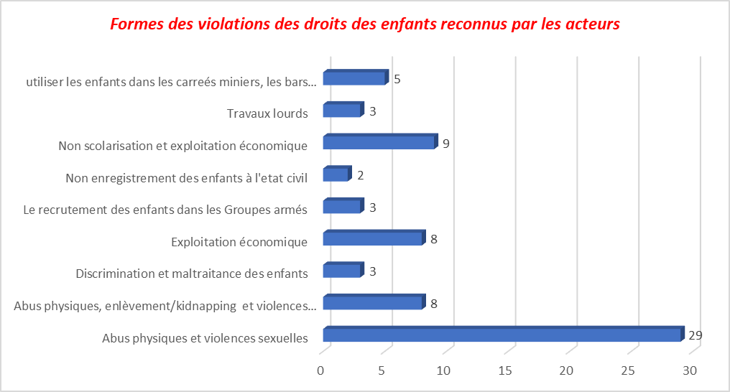

* 1. **CONTRIBUTION FROM CFS SUPERVISORS**
     1. **Practices of actors that care for children victims of violence**

The education and school reintegration of children, vocational and trade training, psychosocial care, referral and counter-referral of identified cases, awareness raising, identification and medical care, are the practices used by the actors contacted for the care of child victims of abuse and sexual violence in the sites under surveys.

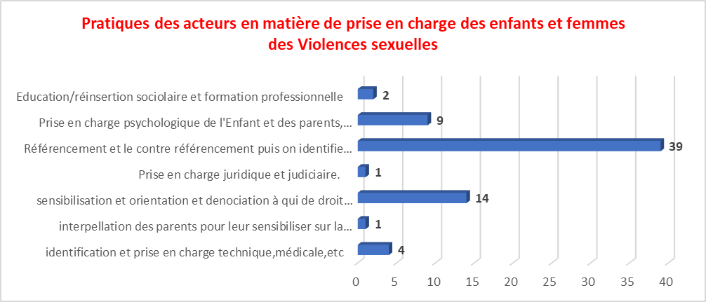

* + 1. **The main protection activities carried out at the CFS**

The main protection activities carried out by the actors contacted are recreational and creative activities, imaginative activities, cultural activities (dance therapies), physical activities, manipulative activities, physical activities, community awareness activities, groups discussions, debates including children's literacy. These activities are those organized in community protection structures such as CFS.

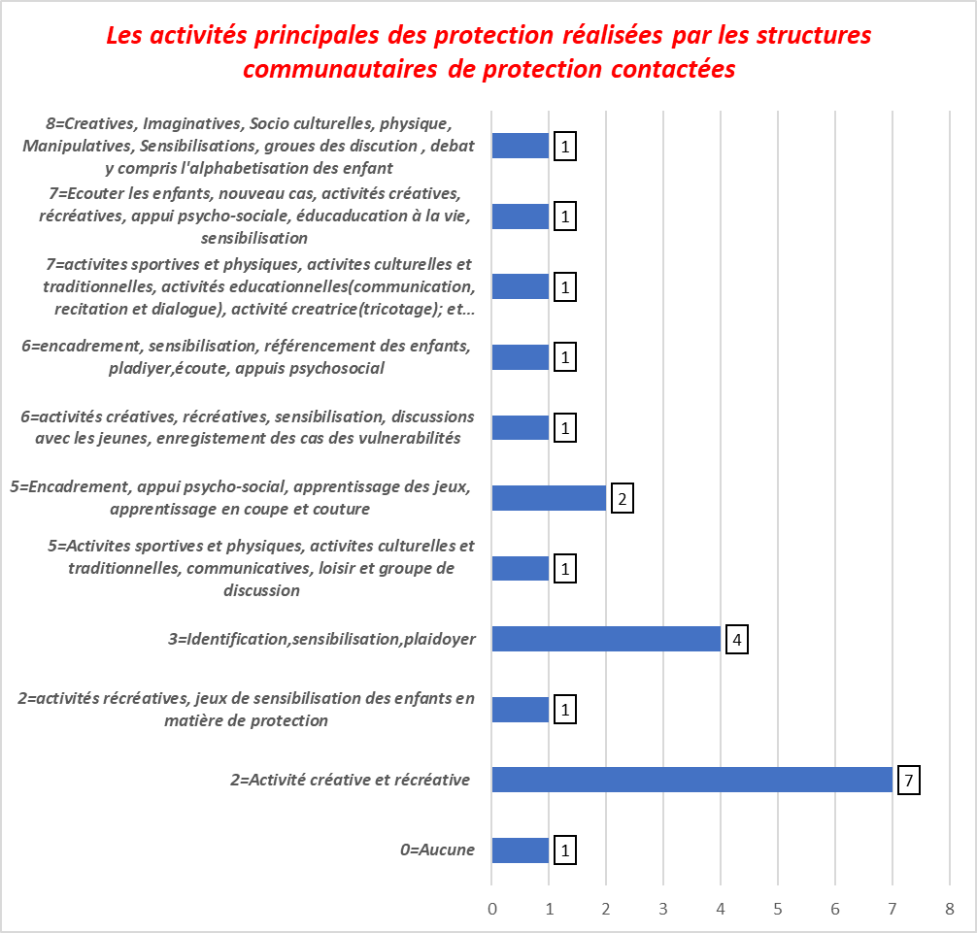

Out of a total of 21 CFS supervisors contacted, 7 use 2 protection activities (creative and recreational activities); 4 carry out 3 activities (Identification, sensitization and advocacy); 2 use 5 activities (sports and physical, cultural and traditional, communicative, leisure and discussion groups); 2 use 6 activities, 2 use 7 activities and 1 structures use 8 activities. By taking inspiration from these answers provided by the supervisors of the CFS, the common points are the creative and recreational activities, the cultural activities and the sports activities, the sensitization of the parents as well as the communicative activities.

The best practices in terms of the supervision of children in Child Friendly Spaces start with community awareness, followed by the establishment of Child Friendly Spaces which include a complete package of activities including '' identification of vulnerable children, their orientation towards specialized care structures, psychosocial care (sports activities, cultural activities, recreational and creative activities, dance therapy, manipulative activities, discussion groups), groups discussion, days of joy,….

* + 1. **Category of children participating to CFS’s activities**

It emerged that 71% of CFS supervisors affirmed that the category of children who participate in CFS activities are girls and boys whose age varies between 2 and 17 years old while 10% say that they are vulnerable children and 9% say they are indigenous children, CAAFG, UC, SE, orphans, displaced and returned children and children living with disabilities.

In addition, 10% of FAC animators say that all children in the community, regardless of quality, gender, cultural, religious or ethnic background, participate in CFS activities. The graph below better illustrates the representativeness of each category of children who participate in CFS activities

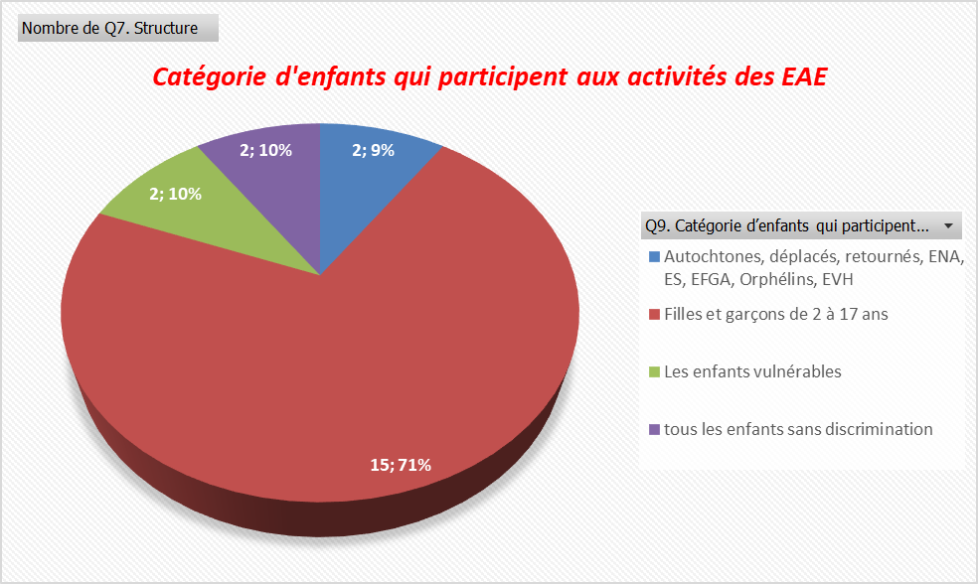

* + 1. **Children participation to CFS activities**

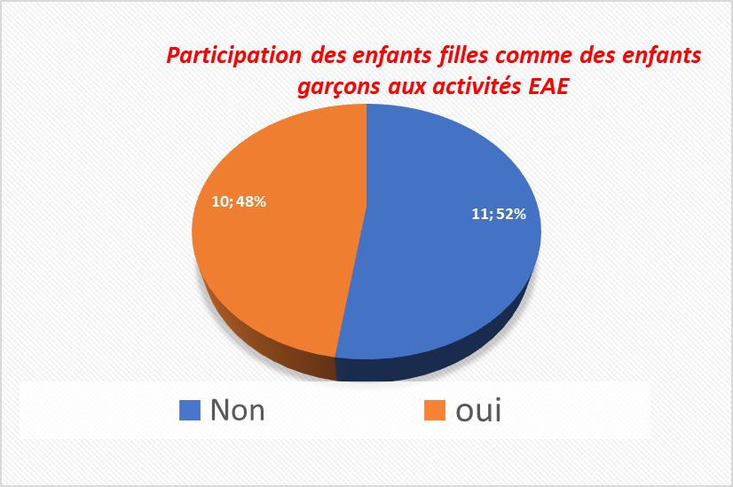52% of the CFS supervisors contacted in the 3 sites (Minova, Bunyakiri and Uvira) say that the girl children participate in the activities of the CFS like the child boys while 48% or 10 supervisors out of 21 did not share the same opinion. It turns out that for some Child Friendly Spaces the representativeness of girls is low, while for others the representativeness of the two categories of children is equal.

* + 1. **Formation Training of CFS supervisors**

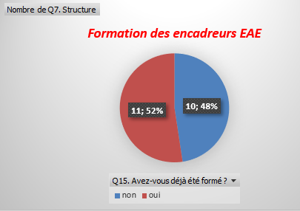During this survey we wanted to know whether the supervisors of the CFSs who accompany children in the Child Friendly Spaces have benefited from any training. Surveys show that 48% of the CFS supervisors were selected and assigned to the CFSs without receiving any training, while 52% had already received training on the protection and care of children in the CFSs, awareness raising, identification of cases of vulnerability, etc.

* + 1. **Tools used by supervisors for different activities in CFSs**

To carry out protection activities in the CFS, the supervisors use recreational kits, footballs, Kaloke, skipping ropes, rambours, markers, cards, chalks, dolls, radios, slates, the swings.

* + 1. **Type of support provided to children by supervisors in the CFS.**

Support, case referral, awareness, medical referral for appropriate care and psychosocial care, socioeconomic reintegration, referral for legal support are the care packages applied by the protection actors for the care of children in sites affected by the study.

* + 1. **Disposal of legal documents by community protection structures.**

Table 2:Number of community structures with legal documents issued by local authorities

|  |  |  |  |
| --- | --- | --- | --- |
| **Structure** | **Legal documents** | | |
| **No** | **Yes** | **Total** |
| **CFS and other NGOs involved in protection** | **5** | **14** | **19** |

Out of a total of 19 CFS supervisors who answered this question, 5 or 26.3% do not have the documents granted by the local authorities which allow them to carry out child protection activities in the community. This 26.6% of community structures do not involve local authorities in child protection activities within the community.

* 1. **CONTRIBUTION FROM LOCAL AUTHORITIES**
     1. **Best practices in child protection as recognized by local authorities**

*Table* ***3*** *Best practices in preventing violence against children known to local authorities.*

|  |  |
| --- | --- |
| Best child protection practices. | n |
| Raising public awareness, denouncing cases of abuse | 14 |
| School reintegration and teacher training on protection | 13 |
| Supervise parents and grant them IGAs | 5 |
| Judge the perpetrators of child abuse and exploitation / Get hold of the perpetrators of abuse and rape | 16 |
| Grand total | **48** |

For community leaders, the best protection practices consist in judging the perpetrators of child abuse and exploitation, sensitizing the community on the denunciation of abuses, ensuring the reintegration of children into school and granting them IGAs for those who are no longer in school age. These practices differ from one health zone to another.

* + 1. **Point of view of local authorities in relation to protection actions carried out by actors in their communities.**

According to community leaders, it is not enough to stop at awareness-raising but rather to strengthen monitoring on the change in community behavior in child protection. Added to this is the strengthening of community structures for protection and punishing the perpetrators of abuse.

* 1. **PARENTS AND TEACHERS’ CONTRIBUTION**

**Table 4: Parents' knowledge of child protection laws**

|  |  |  |  |
| --- | --- | --- | --- |
| **Knowledge of child protection laws** | **Female** | **Male** | **Total** |
| No | 51 | 65 | 116 |
| Yes | 115 | 269 | 384 |
| **Total** | **166** | **334** | **500** |

A total of 76% of those surveyed have knowledge of the laws relating to child protection. The most cited were the Convention on the Rights of the Child, the African Charter on the Rights and Welfare of the Child (ACRWC); the Child Protection Act (LPE); the law on sexual violence, the family code, the constitution of the DRC in its article 72, law 13/16 of the penal code on child protection, non-registration of children in armed groups, law 008 / 2006, etc.

* + 1. **Obstacles to good child protection practices in South Kivu province, DRC.**

Although there are prevention best practices applicable at community level, but this remains low, so for community leaders, low community involvement in defining protection needs can hamper best protection practices.

DRC. However, the non-denunciation of the perpetrators, the amicable settlement of the parents in certain cases of rape (children); the weak appropriation of actions by community members of child protection activities, the poverty of some parents to bear the costs of their children's schooling and which would result in some children not having access to school environments for basic education, certain cultural norms which subjugate the rights of the child / girl, the weak knowledge of the laws which promote the rights of the children, the insecurity, the lack / no change of behavior change as well as the absence of a collaborative framework between local authorities in certain entities where protection activities take place and protection actors constitute a major obstacle to the achievement of best child protection practices in most of the provinces of the DRC.

**Best practices in preventing violence against children**

Table 5 : *Classification of best practices in preventing violence against children in DRC.*

|  |  |  |  |  |  |
| --- | --- | --- | --- | --- | --- |
| N° | Protection issue identified | Bess Practices | Type | Stratégies | Link with INSPIRE strategies |
| 1 | Children psychologically affected by consequences of COVID-19, displacement of the population, activism of armed groups / insecurity, flooding, etc. (psychological effect). | Classroom, CFS par excellence: Promote classrooms in schools as Child Friendly Spaces by excellence by equipping, training teachers on psychosocial support, child protection, referral mechanism.  Indeed, a teacher must embody a second parent of the child able to identify the needs of the child and propose answers | Best response practice | Localizing partnership | Support to parents and child caregivers |
| Para-social workers for the appropriate response to the protection needs of children: Involve para-social workers in the context of supporting children even beyond school spaces. | Best practice | Localizing partnership | Support to parents and child caregivers |
| Psychosocial and mental health support: Individual monitoring of the situation of each child in the classroom and total removal of torture and psychosocial problems in certain schools supported through training of teachers on the key themes of protection and psychosocial care.  Some children whose situation requires specialized care are referred to other care structures at the community level. | Prevention strategy | Localizing partnership | Implementation and enforcement of laws |
| 2 | Poor registration of children in the civil status | Right to registration in isolated areas: Registration of children in the State communal office by proxy (health structures - Civil Registry Office) in remote areas where it is logistically difficult to register in due deadlines. Nurses are empowered to fill the form received from the State agent at each successful birth. The State agent withdraw the forms at a given time without weakened parents, most of the time the mother, having to travel long and unsafe distance to get their children registration. This practice allows equal access to the birth certificates and right to identity. This practice aims to avoid creating precedence for future conflict of identity that has seen DRC paying a huge human cost of endless wars. | Strategy for preventing the risk of children's access to an identity / nationality | Advocacy | Support to parents and child caregivers |
| 3 | Poor knowledge and enforcement of laws relating to children's rights. | Law enforcement: Popularization of laws relating to the protection of children (dissemination in different local languages ​​to ensure better understanding and use in the process of behavior change towards protective communities). | Prevention strategy | Cross Fertilization | Implementation and enforcement of laws |
| Active and two-way sensitization: Through community radios using child protection, education, social cohesion messages for the consolidation of peace with reference to laws and protocol’s themes and give a direct privilege to feedback (collect listeners views in relation to the themes of protection discussed). | Prevention strategy | Risk Communication and Community Engagement (CREC) | Safe environnements |
| Facilitation of interactions at community level: Establishment of youth clubs especially where the media (radio, television) do not exist: in order to allow interactions at the community level on issues related to children's rights. | Prevention strategy | Risk Communication and Community Engagement (CREC) | Safe environnements |
| 4 | Low technical and financial capacity of community structures as well as community animators to provide appropriate responses to the protection needs of children. | Transfer of skills to CBOs / CPCN, (localization): International NGOs, those from the United Nations intensify their collaboration with CBOs in the project areas, which further reinforces community involvement at the lowest level, permanent self-monitoring for the continuity of responses to the immediate needs of children in the right places and at the right times. | Best practice | Localizing partnership | Support to parents and child caregivers |
| Involvement of local authorities in all phases of CBOs/CPCNs empowerment | Best practice | Economic strengthening | Support to parents and child caregivers |
| Localization: Local recruitment of animators / social workers contributes to the sustainability of child protection activities and the transfer of local skills.  Recruitment is done in the communities. Some of these community animators (women and men) come from local organizations and community structures thanks to a well-defined process linked to their experience or the capacity needs. | Best practice | Localizing partnership | Support to parents and child caregivers |
| 5 | Association and use of children in armed forces and groups (CAAFG). | Involvement of the authorities in the process of verifying the separation of children from armed groups: Joint signing of the verification report and the closing of the session by the local authority are strongly encouraged and to be replicated. | Best practice | Localizing partnership | Support to parents and child caregivers |
| Coordination of all actors in the DDR process (Demobilization, Disarmament and Reintegration) to ensure a meaning full package of support is provided to allow them engaging confidently with their journey to self-reliance. | Best practice | Localizing partnership | Support to parents and child caregivers |
| Integrate / focus support for parents of children released from armed forces and groups (Economic recovery). | Prevention strategy | Economic strengthening | Support to parents and child caregivers |
| Contribution to the stability of the most vulnerable children as well as those released from forces and armed groups through the Child DDR process: provide to demobilized children legal and standardized facilities to speed their resilience. The facility can take the form of vulnerability certificates for a period of 2 years (tax exemption). | Best practice | Economic strengthening | Education and practical skills |
| The role of Recope / CPCN (Social Department) in the demobilization / separation of children in AGs: Systematize the establishment of trained, equipped and supported CPCNs in places where they do not exist to facilitate contact with armed groups to release children allegedly associated and / or used by armed groups in violation of their rights. | Best Practice | Localizing partnership | Control and support services |
| Support for Unaccompanied Children (UC), CAAFG, Orphans and Other Vulnerable Children (OVC) by Transitional Foster Families (TFF) in accordance with the guidelines and code of conduct signed before the child's placement | Best Practice | Localizing partnership | Control and support services |
| In some areas where access to information is difficult and security not guaranteed for CPCN members and humanitarian actors, set up focal points (multisectoral) who alert all cases of abuse / forms of violence. | Prevention strategy | Localizing partnership | Implementation and law inforcement |
| Community led effective and more rigorous complaint management (Protective Community) : Establishment of committees including the authorities for the follow-up, identification and management of complaints as well as feedback to the community in the implementation of projects (toll-free number, suggestion box, etc.). | Prevention strategy | Localizing partnership | Implementation and law inforcement |
| Integration of the gender aspect in protection activities (verification of presumptions CAAFG, UC, OVC) and in the process of management of child protection cases by protection actors | Best practice | Localizing partnership | Norms and Values |
| Positive masculinity: the Male Therapeutic Group (GTH) initiated by men who have been sensitized and understood the risks associated with GBV with regard to women and girls to meet prevention and response needs (psychological and referral). The work of these men contributes to the reduction of violence within their households and at the community level. | Best practice | Cross Fertilisation | Norms and Values |
| Positive standards: Training on protection, positive masculinity and femininity as well as the transformation of certain unsuitable standards that are not advancing children protection (i.e., children torture in some churches considering them as associated with witches, FAT Vs FAS). | Prevention strategy | Cross fertilisation : | Norms and Values |
| 7 | Low economic and technical capacity to facilitate coordination and complementarity in responding to imminent child protection needs. | Sustainability: Support to CPCN in IGA, provision for reporting means and multidimensional capacity building, facilitate coordination with other protection communities’ structures at village level (holding of monthly meetings without the participation of humanitarian actors), sharing the report with the department for social services, with a view to providing responses to the cases of affected children and in need (either by referral and direct support by one or the 'other structure). | Best practice | Economic strengthening | Income and economic empowerment |
| Cross fertilization: According to the needs expressed by CPWG member organizations, and depending on the expertise available, member organizations support each other in cross-cutting issues on child protection. This capacity building is planned either during coordination meetings / or extra – ordinary meetings as needed. These skills transfers contribute to the technical capacity to respond to the needs of children at risk and those affected. It has been collectively agreed that no actor has capacities to provide a multisectoral response for a given community in a given area. | Best practice | Cross fertilisation : | Control and support services |
| Joint planning and coordination: Coordination meetings for actors involved in child protection for approach’s harmonization and common awareness-raising, identification, referencing documentation, case monitoring, advocacy, needs assessments as well as monitoring activities planning. | Best practice | Cross fertilisation | Control and support services |
| Case management and referral by traditional and administrative authorities (with tools) to state services and / or specialized community structures and humanitarian actors with the capacity to respond and ensure follow-up and support. It is necessary to systematize the strategy in order to strengthen protective community culture. | Prevention strategy | Localizing partnership | Control and support services |
| 8 | Poor access of children to basic social services and information for behavior change | Sustainability: Involvement of specific categories of communities (with specific needs, for example pygmies, people living with disabilities, albinos, etc.) in defining protection needs and prioritizing them. | Best practice | Localizing partnership | Control and support services |
| 9 | Child abuse and community risks | Community protection risk reduction: Establishment and sharing with the humanitarian community as well as the local authorities of community risk reduction plans in communities at high risk (CRRP). These plans define priority protection risks with their potential causes, consequences, community response plan, implementation deadlines and roles and responsibilities in the monitoring. This plan is made public and include options for emergency cases. | Prevention strategy | Localizing partnership | Control and support services |

# **CONCLUSION**

At the end of this study on the best practices in terms of prevention of violence against children in DR Congo, the overall objective of this research is to understand the best existing practices in terms of child protection and violence prevention strategies that members of the CPSWG use in different provinces of the DRC.

With regards to assigned objectives and after analysis of the data collected, the forms of violence against children that emerged to be commonly recognized included the use of children in mining areas and in bars, sexual violence, non-education, economic exploitation, physical abuse, murders, kidnapping of children, non-registration of children in civil status, recruitment of children into armed groups, early marriage, …

Knowledge and application of child protection laws emerged to be one the important gaps in communities. In fact, the Convention on the Rights of the Child, the African Charter on the Rights and Welfare of the Child (ACRWC); the Child Protection Act (CPA); the law on sexual violence, the family code, the constitution of the DRC in its article 72, law 13/16 of the penal code on child protection, non-registration of children in armed groups, law 008 / 2006 have been listed among areas of needs for attention by the community of child protection actors and should continue to deserve efforts if the curve of violence against children in DRC is to be flatten.

It clearly appeared that actors valued the importance of activities organized in the CFSs and emphasized the need to shift gradually to schools as CFS by excellence among other good practices. Such a school would embed creative and recreational activities, cultural and sports activities, parents' awareness raising as well as communicative activities; referral of cases for medical care, psychosocial care, referral for legal support; socio-economic reintegration, all led by trained teachers to act powerfully as models for children.

Furthermore, replicable best practices ascertained by CPWG members (CPCN, CBOs and NGOs; supervisors of child-friendly spaces, local authorities as well as teachers and parents in charge of children in terms of care) from three DRC provinces dominated by humanitarian context, include but are not limited to:

joint coordination and planning of activities, cross fertilization, active and bidirectional awareness-raising on protection, sustainability of actions through CPCN, transformation of standards management of complaints at community level, transfer of skills to CBOs to sustain actions, advocacy on the right to registration of children in isolated areas, integration the gender aspect in the verification activities of alleged CAAFG and transversal protection, the establishment of alert or denunciation committees for cases of GBV and violation of children's rights, the promotion of classrooms as CFS by excellence and the establishment of para-social workers in the out-of-school context, risk prevention with the establishment and sharing of CRRP, the involvement of the authorities in the process of verifying the separation of children from armed groups and in socio-economic reintegration activities, strengthening of the law, positive masculinity, psychosocial and mental health support and case management through the protection case referral, etc.

Thus, the involvement of all protection actors in the implementation of projects related to child protection with the active participation of communities is and remains the key to success in the implementation of prevention strategies to end violence against children in the humanitarian field.

Last but not the least, this research is not only a paper or another document added to many researches done in this arena but it is more importantly a call for action by all active actors to walk the talk by not reinventing the wheel in the context of emergency where saving lives is key. The above reported, ascertained, validated and collectively approved best practices and strategies, are worth replicating in our zones of actions. Their implementation needs to be aligned to key strategies that emerged including the localizing partnerships that stress on the need to involve grass root communities so that they can shift from old normal that is “what you do for us without us you do it against us” to the new normal “Do for us, with us, by us and gradually without you”. This is the street Child localization model that actors need to shirt to for truly lasting impact in Child protection. Strategies include also the need for large scale risk communication and community engagement along with cross fertilization involving all stakeholders in their context. This is the place for positive norms that are localized to avoid changing local working and positive values by imported values that are not understood as such in African or DRC context (homosexuality, …). Obviously, this calls upon investment in community self-reliance in form of economic empowerment and advocacy for positive changes in policy that support children and women rights and give space to a environment where it is great to be child or a women.

# **6. RECOMMENDATIONS ET LESSONS LEARNED**

**Table 6 Main recommendations formulated by local authorities to improve prevention actions and strategies implemented in the protection of violence against children in South Kivu in DRC**

|  |  |
| --- | --- |
| Labels for lines | ResponsIble |
| Except if there are innovative approaches than the above proven effective best practices, scale up their implementation in DRC. | Actors and donors |
| Support on an annual basis a cross fertilization workshop of two to three days where Protection actors from various provinces or Eastern DRC meet to evaluate the strength of these practices in their context and learn from each other’s | Street Child and other International NGOs to support |
| Intensify awareness-raising measures and popularize the law on child protection and GBV | Local NGOs |
| Improve and implement fully the free education policy | Government |
| Support the establishment of the Children's Court in sites where it does not exist in order to take care of children in conflict with the law (CCL) | Congolese Ministry of Justice |
| Support the rehabilitation of school infrastructure, in order to better serve as a protective framework par excellence | Protection and education partners / Financial partners |
| Support the strengthening of the technical and financial capacities of local protection actors, including the commentary structures (localization), support of the STPE and other partners. | Protection partners / financial partners |
| Strengthen the capacity of members, provide protection structures with kits that can help them perform their tasks |
| Strengthen awareness-raising and training on child protection |
| Strengthen and put in place where this does not exist and support a framework for exchange (coordination) on PE at the local level |
| Organize debates and exchange of experiences between protection actors and the community, training of local leaders |

In view of the foregoing, support for organizations / active child protection actors working in difficult areas should benefit from appropriate support in order to strengthen their strategies at community and institutional level for the sustainability of actions and ownership at the grassroots level. Also the child being at the center of all issues, promote his rights through the appropriate activities for his development.

**LESSONS LEARNED**

The study received massive support from all participants, including CBOs, NGOs, CFS supervisors, parents and teachers in charge of children, and local authorities who provided answers to the questions asked.

The questions being adapted to the context of the environment and reflecting the strategies contained in the INSPIRE manual; this study succeeded in collecting the relevant data in relation to child protection and that for some survey participants, the mapping made it possible to understand that the same best practices as stated in the study are carried out in the large part of the country (DRC).

The presentation of the final results knew the participants of several protection actors from the provinces of Kinshasa, Ituri and North Kivu and which actors have activities across the country and they had significantly contributed to the results in terms of generalization of the results which remain relevant. and beneficial in the humanitarian context.

# **BIBLIOGRAPHIQUES REFERENCES**

Krug E.G. et al. (Edited by). World report on violence and health. Geneva, World Health Organization, 2002

UNODUC, Planning for the implementation of the United Nations Model Strategies and Concrete Measures on the Elimination of Violence against Children in the Context of Crime Prevention and Criminal Justice Checklist, New York , 2015.

Unicef, Unite for Children, sexual exploitation and abuse of children in West and Central Africa: Evolution of the situation, progress made and challenges to be overcome since the Yokohama Congress (2001) and the Arab-African Conference in Rabat ( 2004)., 2008.

Unicef ​​/ Inter-Parliamentary Union, Eliminating Violence Against Children, Guide for Parliamentarians N ° 13 - 2007.

WHO, 2021. https://www.who.int/fr/news/item/11-07-2016-new-strategies-to-end-violence-against-children, accessed on 04-30-2021

World Health Organization, INSPIRE Handbook, Seven Strategies to End Violence Against Children, 2016.

# **APPENDIX I. THEMES ADDRESSED IN CHILD PROTECTION**

|  |
| --- |
| key theme related to the protection of children approached in South Kivu in the areas surveyed |
| Awareness, identification, orientation, data monitoring and alert |
| DDR Child, fight against early marriage and sexual and gender-based violence. |
| Legal and judicial assistance as well as psychosocial, medical referral |
| Education (school sponsorship of orphan children, children born of rape, separated children and unaccompanied children, Awareness raising on the registration of children in civil status to prevent the risk of statelessness |
| IDTR, education and the fight against sexual abuse |
| EAFGA, ENA-ES, Children in difficult situation |
| Cross protection, LPT, GBV etc. |
| Réintégration |
| Prevention of violence against children |
| Human rights |
| Registration of births at the civil status, nutrition, popularization of laws relating to child protection |
| Fight against discrimination against pygmy and albino children |
| Fight against sexual violence against children |
| Empowerment |
| Economic reintegration, Strengthening the links of children in the community |
| Child in difficult situation, Child with physical and mental disabilities, Child in conflict with the law, Street child and Child in the street, CAAFGA, ENA |
| Fight against all forms of child abuse |
| Prevention, protection and defense of children's rights |
| Program and sport on the protection and fight against sexual violence |
| Rights and duties of the child |
| Training, literacy |
| Training of structures, documentation and responses |

# **APPENDIX II. INTERVIEWED STRUCTURES**

|  |
| --- |
| Name of the structure |
| Action Communautaire Pour la promotion Paysanne à l'origine des ex combattants (ACPP/RDC) |
| Action pour la protection de la santé humaine et animale '' APROSHAV'' |
| DIRECTION DE COOPERATION SUISSE (DDC) |
| Agissons Ensemble pour le Développement Durable (AEDD) |
| Aide Rapide aux Victimes des catastrophes ‘’ ARVC’’ |
| DIVAS NORD KIVU |
| APDUD |
| DIVAS SUD KIVU |
| DIVIGENRE SUD KIVU |
| WAR CHILD HOLLAND |
| ARCHE D'ALLIANCE |
| CPWG NATIONAL (SAVE THE CHILDREN) |
| CPWG NORD KIVU (UNICEF) |
| CPWG ITURI (UNICEF) |
| ASSOCIATION DES VOLONTAIRES POUR LES VULNERABLES, AVOV-ONGDH |
| Association pour la Non-Violence aux Êtres Vivants Enfant Femme Faune et Flore '' ANOVEV EF3'' |
| ATCD |
| AVORAD |
| AVPE |
| AVREO |
| CADI asbl |
| CARECO |
| ACAD asbl |
| Centre de Développement Intégral de l'Enfant Rural '' CEDIER'' |
| EBENEZER |
| EMERGENCE RDC |
| EPDH /ASBL |
| Genre Famille et Enfant sud - kivu |
| IDAV asbl |
| JRS |
| LFPGE |
| Mama Tushirikiane |
| Mutuelle des femmes paysannes pour le développement et la santé en Afrique '' MFPDSA'' |
| CBO AMANI |
| CBO AMANI NUMBI |
| CBO CHEYA |
| CBO MAMA AMKENI |
| CBO MAMA TUUNGANE /UFPAV |
| CBO MAMA TUUNGANE KALUNGU |
| Paix et Développement pour Tous '' PDT'' |
| PAYSANS ACTIFS CONTRE L’IGNORENCE ET LA FAIM « PACIF » |
| POPOLI FRATELLI - RDC |
| PROSPADEC-asbl |
| RADIO COMMUNAUTAIRE BUNDADONO 96. OMHZ/MINOVA |
| Radio communautaire Bunyakiri (RCB) |
| RADIO COMMUNAUTAIRE MINOVA(RTCM) |
| Radio RCA/Bunyakiri |
| CPCN |
| SAVE THE CHILDREN INTERNATIONAL |
| Service des affaires sociales antenne de Bunyakiri, Uvira, Minova (DIVAS) |
| TPO DRC |
| Union des femmes pour la paix (UFP asbl) |
| Women and children Protection '' WCP'' |
| World Vision |
| Street-Child |
| Union Paysanne pour la Protection Rural Intégrée (UPPRI) |
| Centre d’Apprentissage des Jeunes Enfants Désœuvrés |
| BIFERD |
| Actions concrètes pour la protection de l'enfance |

# **APPENDIX III. DATA COLLECTION TOOLS /SURVEY QUESTIONNAIRES**

**DATA COLLECTION GRID ADDRESSED TO HEADS OF NGOs, CCPN, CBO, RADIO WORKING IN CHILD PROTECTION**

Hello Dear research participant,

It is within the framework of research on **best practices in the prevention of violence against children** that we are carrying out this study and we ask you to support us in providing information relevant to the questions listed below.

NB: The information provided will be treated with strict confidentiality, from the time it is collected to the presentation of the results.

***Context and rationale for the study***

This research is being conducted with the aim to understand existing best practices in child protection and violence prevention strategies that members of the Child Protection Sub working Group (CPSWG) use in humanitarian contexts. However, documenting these learnings in a report can be shared to improve **knowledge about violence prevention** and **Child Protection** preparedness nationally and globally.

The report produced and the learnings generated will be used to train the Child Protection Sub Cluster (CPSP) at the national level. These Child Protection best practices will be used to improve tools and approaches used by actors in humanitarian contexts.

*Q1. Do you agree to participate in this research ? 1. Yes 2. No*

***Presentation of the Structure***

Q2. Structure localization: 1. Uvira 2. Bunyakiri 3. Minova

Q3. Structure’s Name :…………………………………………………………………………………………………………….

………………………………………………………………………………………………………………………………………..

Q4. Contact/Tel. Key informant (If more information is needed) ………………………………………………….….

Q5. Zone where you intervene :……………………………………………………………………………………………………

Q6. Key theme related to child protection : ……………………………………………………………………..

**Proper questions**

Q7. What are the different forms of child rights violations that you face in your areas of intervention?

………………………………………………………………………………………………………………………………………..

Q8. How do you identify cases of abuse / violation of children's rights in your areas of intervention?

………………………………………………………………………………………………………………………………

………………………………………………………………………………………………………………………………

………………………………………………………………………………………………………………………………

Q9. How do you document cases of abuse / violation of children's rights in your areas of intervention? (Please give details)

………………………………………………………………………………………………………………………………

Q10. How do you provide care for victims of violations, especially children and women, in your areas of intervention?

………………………………………………………………………………………………………………………………

………………………………………………………………………………………………………………………………

Q11. Do you refer children that are victims of abuse / violations to the appropriate care service?

1. Yes 2. No

Q12. If so, what are these services that you collaborate with for referral of cases?

………………………………………………………………………………………………………………………………

Q13. Do these structures exist in these areas from where you are intervening?

1. Yes 2. No

Q14. What is your level of collaboration and / or coordination with other actors in your area of ​​intervention with the same package (child protection) in order to provide responses to child protection’ needs? And what is your level of complementarity?

………………………………………………………………………………………………………………………………

Q15. How do you involve the local authorities in the implementation of child protection response?

………………………………………………………………………………………………………………………………

Q16. How do you involve the community in the implementation of child protection response?

………………………………………………………………………………………………………………………………

Q17. Are there other functional community child protection structures in your different zones where you are intervening? 1. Yes 2. No

Q18. If yes, Name them (by talking about their main actions / activities)?

………………………………………………………………………………………………………………………………

Q19. Do you have a funding for the implementation of child protection activities?

1. Yes 2. No

Q20. If Yes, what kind of support do you have?

………………………………………………………………………………………………………………………………

………………………………………………………………………………………………………………………………

Q21. Have you had capacity building/training sessions on child protection and children rights from child protection actors?

1. Yes 2. No

Q22. If Yes, How many times?..................................

Q23. By who (actors who supported capacity building) and in what?

………………………………………………………………………………………………………………………………………………………………………………………………………...……..........................................................................................

Q24. Do you have moments of exchange of experiences in matters of child protection?

1. Yes 2. No

Q25. If Yes, how are they done?

………………………………………………………………………………………………………………………………………………………………………………………………………………………………………………………………………………………………………………………………………………...……..........................................................................................

Q26. What are the results of these exchanges after their capitalization?

……………………………………………………………………………………………………………………………………………………………………………………………………………………………………………………………………………..

Q27. Do you share best practices and learnings from your various child protection interventions? 1. Yes 2. No

Q28. If Yes, what channel do you use to share ideas and these experiences? (Check multiple answers)

1. Training workshops 2. Meetings, 3. Advocacy sessions 4. Documentation (module, report, ..)

5. Others to be specified ……………

Q29. If there are any, do you popularize the laws on child protection in your areas of intervention? 1. Yes 2. No

Q30. If Yes, which ones?

………………………………………………………………………………………………………………………………………

Q31. What is the scope of your interventions in the field?

1. Schools 2. Churches 3. Health facilities 4. In the community 5. Others to be specified …………………………….

Q33. What are the best protection practices to prevent the violence against children that you observe in your community (Child protection actors, parents, teachers, ...)?

………………………………………………………………………………………………………………………………………………………………………………………………………………………………………………………………………………

Q34. What are the challenges encountered during the implementation of these best practices on child protection?

………………………………………………………………………………………………………………………………………………………………………………………………………………………………………………………………………………

Q35. What are your recommendations or suggestions to promote better documentation and better sharing of best practices?

……………………………………………………………………………………………………………………………………………………………………………………………………………………………………………………………………………..

***Thank you for your participation***

**SURVEY QUESTIONNAIRE FOR POLITICAL-ADMINISTRATIVE AUTHOTIRIES**

**(**Sub-division for Youth; sub-division for gender, family and child ; sub-division for social affairs, UEPN DDR, PLVS, SECAS)

**Code of the respondent** :

Hello, my name is…………………………………………………………………………

In the context of child protection, TPO DRC with the funding of Street Child is conducting research in your entity to understand existing best practices in child protection and violence prevention strategies. To do this, we thank you in advance for your contribution to this work by answering the questions below.

We promise the anonymity of your answers and we guarantee confidentiality in the processing of this data.

*Q1. Do you agree to participate in this research?* *1. Yes 2****.*** *No*

**Information on the intervewee**

Q2. Sex : 1.Male 2.Female Q6. Age (in Year) :

Q3. Province :……………………………… Q7. Health Zone……………………………………

Q4. Locality/village …………………………… Q8. Tel/Mail : Key Informant :……………………….

Q5. Quality of the key informant ………………………… Q9. Structure : ……………………………………

**QUESTIONS**

Q10. Are there any actors involved in child protection in your entity?

1. Yes 2. No

Q11. If Yes, please mention them :……………………………………………………………………………………….

*Q12.* Do you know of the existence of laws prohibiting violent punishment of children by parents, teachers or caregivers? 1. Yes 2. No

Q13. Are there laws criminalizing the sexual services and exploitation of children? 1. Yes 2. No

Q14. Are there laws preventing heavy drinking? 1. Yes 2. No

Q15. Are there laws restricting the access of young people to firearms and other weapons?

1. Yes 2. No

Q17. Are you satisfied with the child protection actions or interventions carried out by organizations working on children's rights in your entity?

1. Yes 2. No

Q18. If Yes, at what level? (of child protection interventions)?

………………………………………………………………………………………………………………………………………………………………………………………………………………………………………………………………………………

Q19. At what level are you involved in the promotion and protection against child violence? Please support this argument with real life examples!

………………………………………………………………………………………………………………………………………

Q20. Is there coordination between you as State Structures and child protection organizations (CPCN, CBO, NGOs)?

1. Yes 2. No

Q21. If Yes, at what level does this coordination intervene in child protection actions?

………………………………………………………………………………………………………………………………………

Q22. What are the best protection practices against child violence that you observe in your community (Child protection actors, parents, teachers, ...)?

………………………………………………………………………………………………………………………………………

Q23. And what is your perspective on these child protection actions or interventions?

………………………………………………………………………………………………………………………………………

Q24. What do you think can hinder these best protection practices in the community?

………………………………………………………………………………………………………………………………………

Q25. What are your recommendations or suggestions for improving these best child protection practices that are found in the community?

………………………………………………………………………………………………………………………………………

***NB****: If the space provided to contain the corresponding answer is not sufficient, the interviewer can mark the answer on the back of the page, while indicating the number of the question.*

**SURVEY QUESTIONNAIRE FOR PARENTS-TEACHERS-CHILD CAREGIVERS**

**(**Sub-division for Youth ; sub-division for gender, family and child ; sub-division for social affairs, UEPN DDR, PLVS, SECAS)

**Code of the respondent**:

Hello, my name is…………………………………………………………………………

In the context of child protection, TPO DRC with the funding of Street Child is conducting research in your entity to understand existing best practices in child protection and violence prevention strategies. To do this, we thank you in advance for your contribution to this work by answering the questions below.

We promise the anonymity of your answers and we guarantee confidentiality in the processing of this data.

*Q1. D*o you agree to participate in this research? *1. Yes 2. No*

**Information of the interviewee**

Q2. Sex: 1. Male 2. Female Q6. Age (in Year):

Q3. Civil status: / …… / 1. Married 2. Single 3. Widowed 4. Divorced / Separated

Q5. Profession: …………………………………………………………………………………………

Q6. Household size: ……………………………

Q7. Number of children with school-age: ……………………………

Q8. Residence: ………………………………………………………………………………

**QUESTIONS**

Q9. Do you have any knowledge on the different forms of violence that children are victim of in your entity or community? 1. Yes 2. No

Q10. If Yes, Which ones and at what age:

1. abuse / …………… / 2. harassment / …………… / 3. violence between young people / ……………… / 4. violence by the intimate partner / ………. / 5. Sexual violence / …… / 6. Emotional or psychological violence / …………… /

Based on your experience, can you list in order of priority the health consequences of violence against children in your home that are often encountered?

Q11. Among the Mental Disorders below, list those that children are victims of.

Depression /…../ Anxiety /… ../ mania /…. / Post traumatic stress disorder /…./Run away/…../ others to be specified :: ………………………… ..

Q12. Q12. According to you, what are the elements on that cause of traumas in children?

Fractures /…./ Burns /…../ Internal trauma /…../ Head trauma / …… / Family abuse /… ../ others to be specified :: ………………………… ..

Q13. What Transmissible Diseases and Risk Behaviors that you are aware of?

Alcohol and drugs /…../ HIV / …… / Unsafe sexual practices /… ../ Multiple partners / …… / Sexually transmitted diseases /… ../

Q14. What is your knowledge on Maternal and Child Health?

Death (including fetal death) /… ../ Unintended pregnancy and teenage pregnancies / …… / Complication during pregnancy /……../

Q15. What Non transmissible Diseases and Risk Behavior that you are familiar with?

Obesity / …… / Alcohol / …… / Sedentary lifestyle / …… / Smoking /……. /

Q16. Are you aware of the existence of laws prohibiting violent punishment of children? /……./ 1. Yes 2. No

If yes, name them …………………………………………………………………………………………………………… ..

Q17. Are you aware of the existence of laws making sexual services and exploitation of children offenses in the community? /…../ 1. Yes 2. No

If yes, name them …………………………………………………………………………………………………………….

Q18. Are you aware of the existence of laws preventing alcohol abuse? / …… / 1. Yes 2. No

Q19. Are you aware of the existence of laws restricting the access of young people to firearms and other weapons? /……./ 1. Yes 2. No

Q20. Do you know that there are laws that prohibit or prevent heavy drinking? / …… / 1. Yes 2. No

Q21. In your community, are there customs and traditions that prohibit abuse / violations against children? / …… / 1. Yes 2. No

Q22. If so, cite them if applicable in your community?

……………………………………………………………………………………………………………………………

Q23. Are child protection laws popularized in your community? / …… / 1. Yes 2. No

Q24. If so, by whom?

……………………………………………………………………………………………………………………………

Q25. Does your custom / tradition take action in the promotion of children's rights in your community? / …… /

1. Yes 2. No

Q26. Do you encourage boys and girls to do the same housework or schoolwork? /… ../ 1. Yes 2. No

Q27. Do your traditions take action in promoting gender equality (men-women) in your community? / …… /

1. Yes 2. No

Q28. Are traditional authorities involved in activities related to the protection of the rights of the child? /…../

1. Yes 2. No

Q29. What are the attitudes of the traditional authorities towards the application of standards relating to the rights of the child? /……. / 1. Positive 2. Negative

Q30. What do you think are you community’s social norms that do not contribute to child protection?

……………………………………………………………………………………………………………………………………

Q31. Are child protection laws enforceable in your community? /…. / 1. Yes 2. No

Q32. If so, by whom?

…………………………………………………………………………………………………………………………………… ………………………………….

Q33. Are there community mobilization sessions on the rights of the child? / …… / 1. Yes 2. No

Q34. Are early/forced marriages happening in your community? / …… / 1. Yes 2. No

Q35. Do you encourage forced marriages in your family? / …… / 1. Yes 2. No

Q36. In the event of rape, is the executioner referred directly to the judicial authorities? /…. / 1. Yes 2. No

Q37. If not, the following options are applicable? /……. / 1. Amicable settlement 2. Processing of the case before a traditional authority 3. Others to be specified ………………………………………………………………… ...

Q38. Do you encourage girls and boys to work together in your family? (e.g. everyone does laundry, goes to the field, draw water. 1. Yes 2. No

Q39. Are there places in your community that are very dangerous for children? /…. / 1. Yes 2. No

Q40. What places in your community do you are a risk to child protecting? …………………………………………………………………………………………………………………………………… …………… ..

Q41. Do you often send your children there? / …… / 1. Yes 2. No

Q42. How do you go about securing your children against violations in public spaces? (schools, bars, restaurant, playgrounds, etc.

…………………………………………………………………………………………………………………

Q43. Are there appropriate mechanisms that you are implementing to make children safer when population are moving?

…………………………………………………………………………………………………………………………………… ………………………………….

Q44. Do you accompany your children in community activities (sports and recreational)? /…../ 1. Yes 2. No

Q45. If yes, how?

……………………………………………………………………………………………………………………………

Q46. Are there Areas in your entity notorious for Child Abuse / Violence? /…./ 1. Yes 2. No

Q47. If so, can you name these Zones?

……………………………………………………………………………………………………………………………………

Q48. Do you keep children safe from unhealthy places? /.…./ 1. Yes 2. No

Q49. What do you think are the factors that hinder the consideration of children's environmental safety in humanitarian interventions?

………………………………………………………………………………………………………………………

………………………………………………………………………………………………………………………

Q50. Do you benefit from home visits by members of CPCN or any child protection organization / structure? /…../ 1. Yes 2. No

Q49. What do you think are the factors that hinder the consideration of children's environmental safety in humanitarian interventions?

………………………………………………………………………………………………………………………

………………………………………………………………………………………………………………………

Q50. Do you benefit for home visits from members of CPCN or any child protection organization / structure? /…../ 1. Yes 2. No

Q53. Do you support children in personal promotional activities (sports, leisure, games, etc.)? /…../

1. Yes 2. No

Q54. Do you have moments of interaction with children at home / at school? /…../ 1. Yes 2. No

Q55. Do you have the courage to bring or denounce the offenders to justice in cases of violence or abuse against children or young girls? /…../ 1. Yes 2. No

Q56. Did you know that non-reporting is punishable by law? /… ../ 1. Yes 2. No

Q57. Are there community groups aimed at supporting parents and caregivers in your entity? /…../

1. Yes 2. No

Q58. Do organizations intervening in protection include the economic empowerment (IGA activities) of parents and caregivers of their various interventions include? /…. / 1. Yes 2. No

Q58A. If so, what kinds of activities do these parents benefit from?

…………………………………………………………………………………………………………………………………… ………………………………….

Q59. What, in your opinion, are the factors that hinder the economic empowerment of parents and caregivers in humanitarian interventions (with CBOs, CPCN, NGOs)?

……………………………………………………………………………………………………………………………………

Q60. In your community / schools, are there services / structures to fight and support child protection? /….../

1. Yes 2. No

Q61. If yes, name them …………………………………………………………………………………………………… ..

Q62. Are there activities carried out by organizations that fight against child rights abuses / violations? /…. /

1. Yes 2. No

Q63. Is there a valid psychical support service organization in your community? / …… /

1. Yes 2. No

Q64. Are there valid medical care services in your community? / …… /

1. Yes 2. No

Q65. Are there valid legal support services in your community?

1. Yes 2. No

Q65A. Are all your school-age children going to school? /……../

1. Yes 2. No

Q66. If not, how many children go to school: …………………………………

Q67. Are children well supervised (protection) by their teachers when at school? / …… /

1. Yes 2. No

Q68. In school programs, are there courses integrating notions of prevention of sexual abuse / violence and violence against children? /…../

1. Yes 2. No

Q69. Are there life education classes that children benefit from? / …… /

1. Yes 2. No

Q70. Do these courses cover notions of sexuality and the prevention of child abuse / violence? /……./

1. Yes 2. No

Q71. Does the school where the child studies from promote community work in groups (men-women)? / …… /

1. Yes 2. No

Q72. What are the major strategies you are putting in place within your institution / schools / community to fight violence against children?

…………………………………………………………………………………………………………………………………… ………………………………….

Q73. What are the practical effects or changes that these strategies have in the community or in your surrounding?

…………………………………………………………………………………………………………………………………… ………………………………….

Q74. What are your suggestions or recommendations to the government or to child rights protection organizations that will help in enabling the knowledge of protection laws in your community?

……………………………………………………………………………………………………………………………

***NB****: If the space provided to contain the corresponding answer is not sufficient, the interviewer can write the answer on the back of the page, while indicating the number of the question.*

**INTERVIEW GUIDE WITH SUPERVISORS IN CFS (CHILDREN'S FRIENDLY SPACE)**

**Code du respondent** :

Hello, my name is…………………………………………………………………………

In the context of child protection, TPO DRC with the funding of Street Child is conducting research in your entity to understand existing best practices in child protection and violence prevention strategies. To do this, we thank you in advance for your contribution to this work by answering the questions below.

We promise the anonymity of your answers and we guarantee confidentiality in the processing of this data.

*Q1.* o you agree to participate in this research? *1. Yes 2. No*

**Information about the interviewee**

Q2. Province ………………………………………………….. Q3. Heath Zone ……………………………………………..

Q4. Locality/village………………………………………….. Q5. Key Informant :……………………………………………

Q6. Quality of the key informant………………………………….. Q7. Structure : …………………………………………………..

**QUESTIONS**

Q8. What are the main child protection activities that you do in these Child Friendly Spaces?

………………………………………………………………………………………………………………….

………………………………………………………………………………………………………………….

Q9. What categories of children participle to you CFS activities?

……………………………………………………………………………………………………………………………………………………………

Q10. What categories of children that participate more in your CFS?

…………………………………………………………………………………………………………………………………………………………………………………………………………………………………………………………………………

Q11. Do you think that girls participate more than boys in your CFS?

1. Yes 2. No

Q12. If No, what are the main reasons? (3 to 5 are enough)

…………………………………………………………………………………………………………………………………………………………………………………………………………………………………………………………

Q13. How long do activities take place in the CFS that you do manage?

………………………………………………………………………………………………………………………………………

Q14. How many mentors and peer educators does your CFS have?

………………………………………………………………………………………………………………………………….

Q15. Have you ever been trained? 1. Yes 2. No

Q16. If Yes, on what theme? (Please specify)

……………………………………………………………………………………………………………………………………………………………………

Q17. Are Kits available in your CFS? 1. Yes 2.No

Are Kits available in your CFS?

Are Kits available in your CFS?

Q18. If Yes, which one for each type of activity?

…………………………………………………………………………………………………………………………………

Q19. Do parents of these children attend / accompany children to CFS activities?

1. Yes 2. No

Q20. If Yes, Please estimate the number of parents who attend / accompany their children to EEA?

…………………………………………………………………………………………………………………………

Q21. What other protection structures does your CFS collaborate with?

………………………………………………………………………………………………………………….

Q22. Have you received any cases of child abuse / violence referred to the CFS?

1. Yes 2. No

Q23. If Yes, What type of support did you provide?

………………………………………………………………………………………………………………….

………………………………………………………………………………………………………………….

Q24. Do you have legal documents offered by local authorities for the maintenance of your CFS?

1. Yes 2. No

Q25. Are local authorities involved in maintaining security and promoting CFS?

1. Yes 2. No

Q26. What are the challenges or difficulties that you encounter in your activities?

……………………………………………………………………………………………………………

……………………………………………………………………………………………………………

Q27. What are your recommendations in order to improve childcare activities in child-friendly spaces?

……………………………………………………………………………………………………………

……………………………………………………………………………………………………………

***NB****: If the space provided to contain the corresponding answer is not sufficient, the interviewer can mark the answer on the back of the page, while indicating the number of the question.*

